

Union County
Union County ANR Newsletter
January/February 2024
Cooperative Extension Service



Grain Day will be Jan 24 at 10am. If you need your private applicator license renew you must attend all speakers. Lunch will be provided, please RSVP by Jan 19 to 270-389-1400 or katie.n.hughes@uky.edu

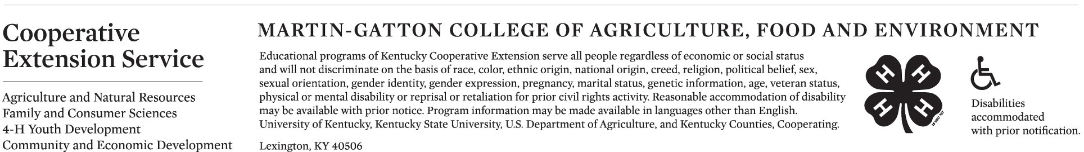

Excellent Corn and Soybean Yields Despite Low Rainfall Totals
Dr. Chad Lee, UK Grain Crops Specialist and Matthew Dixon, UK Senior Meteorologist

Both corn and soybean finished strong across Kentucky despite lower total rainfall amounts across most of the state. The 2023 Kentucky corn crop is estimated by the Kentucky Office of the United
States Department of Agriculture National Agricultural Statistics Service (USDA-NASS) at 183 bushels per acre, up 17% from 2022, making the second largest corn crop on record. The 2023 Kentucky soybean crop is estimated by USDA-NASS at 55 bushels per acre, a 7.8% increase from 2022. Yet, the
Kentucky rainfall totals are below normal from April to September 2023 across most of the state (Figures 1 and 3).
Corn in Kentucky often experiences peak water demand in July while soybeans often need most water in July or August. On average across the state and in western Kentucky, rainfall was above average for
those two months. The higher rainfall in April made planting a challenge but started off the season with excellent soil moisture. While temperatures from April to September averaged near normal to below normal for most of the state (Figures 2 and 4), they were below normal for April, May, and June, which caused the crops to demand less water. Both temperatures and rainfall increased to
above normal in western Kentucky during July when corn needed water the most. August, historically the warmest month in Kentucky, experienced slightly cooler temperatures on average, allowing crops
to stretch the seed filling period a little longer in many fields. For most of the state, these weather patterns were favorable for excellent crop production.
These first set of graphs do not tell the complete story and rainfall totals can be misleading sometimes. Fulton County received 30.54 inches of rain from April 1 to September 30, 2023, suggesting more than adequate rain- fall (Figure 5). By comparison Union County, Marshall County and Todd County received 20.62 inches, 23.11 inches and 28.5 inches, respectively. These numbers suggest that Fulton County experienced the best growing conditions. However, Fulton County was hit with over 12 inches of rain in 3 days in early August. Receiving 40% of the total rainfall in 3 days is not healthy for the crops and skews the total amount of water used by the crops. In fact, that much rain that fast hurt yields in Fulton County. Fulton County reported the most rainfall of these counties, but corn and soybean likely were more stressed in Fulton County than in the other three.
All four locations in Figure 5 experienced a dry spell from part of May into June. Fulton County had 11 days without rain, one day with 0.14 inches and 9 more days without rain. Todd County experienced 17 days without measurable rainfall. Marhsall County received no rain for 21 days from May 21 to
June 10. Union County received 0.02 inches over 21 days from May 17 to June 6. Yet, each of these
counties received measurable rains prior to and following the dry spells. Most of these counties received timely rainfall in July and the early part of August. Again, these rainfall events in July and August
coincided with peak water demand for corn and soybeans in most fields. The heavy rainfall in
late August may have helped double-crop soybeans but likely did little for the corn. As we mentioned earlier, the deluge in Fulton County was harmful to the crops.

Rainfall totals and average temperatures do not tell a complete story regarding yield. Timing and intensity of that rainfall combined with daily temperatures relative to crop development explain why corn and soybeans yielded so well in a season when rainfall totals were lower across most of the state. While most farmers, crop
consultants and university agronomists stressed about having enough rain during the growing season, hindsight tells us that most fields received enough rain exactly when the crop needed it. If we knew the outcome before starting, I think all of us would gladly take this weather pattern again.
Excellent Corn and Soybean Yields Despite Low Rainfall Totals, Continued;
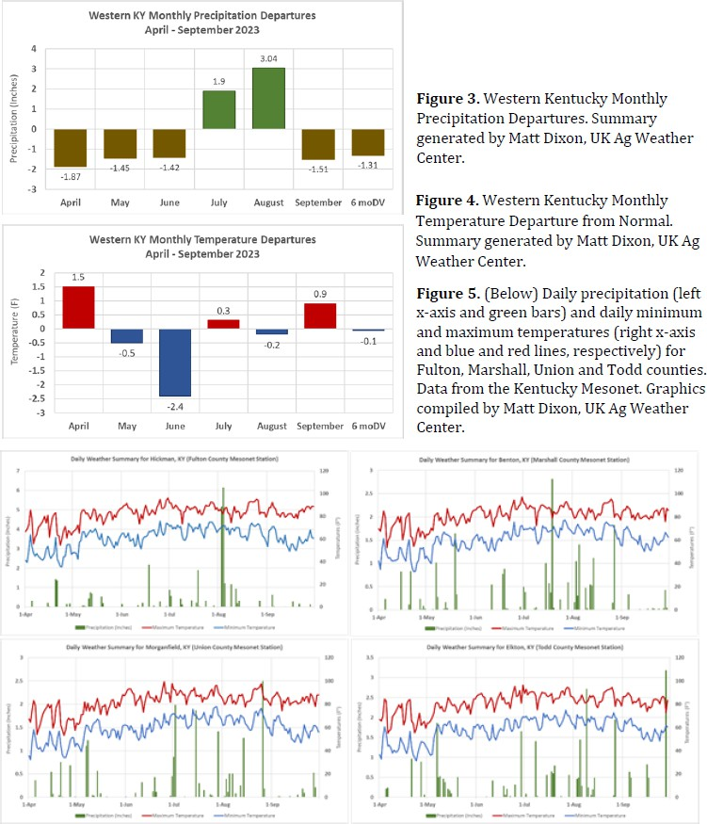

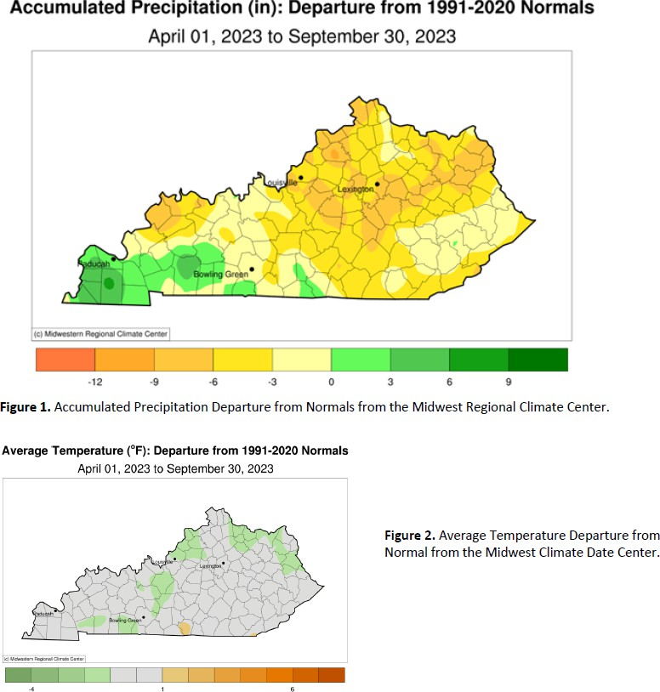

Winter Ag Seminar

You are invited to a free seminar for understanding soil test results
and connecting solutions with economics
Galynn Beer will be presenter

Tuesday January 30,2024
9:00 - 3:00pm
Union County Extension Office 1938 US Hwy 60 West
Morganfield, KY 42437

Bring your soil test results to follow along and ask questions
Lunch will be provided

Please RSVP to:
Rob Marquardt (270) 217-1378
By January 26, 2024

Lunch Sponsor: Jim David Meats There will be door prizes.
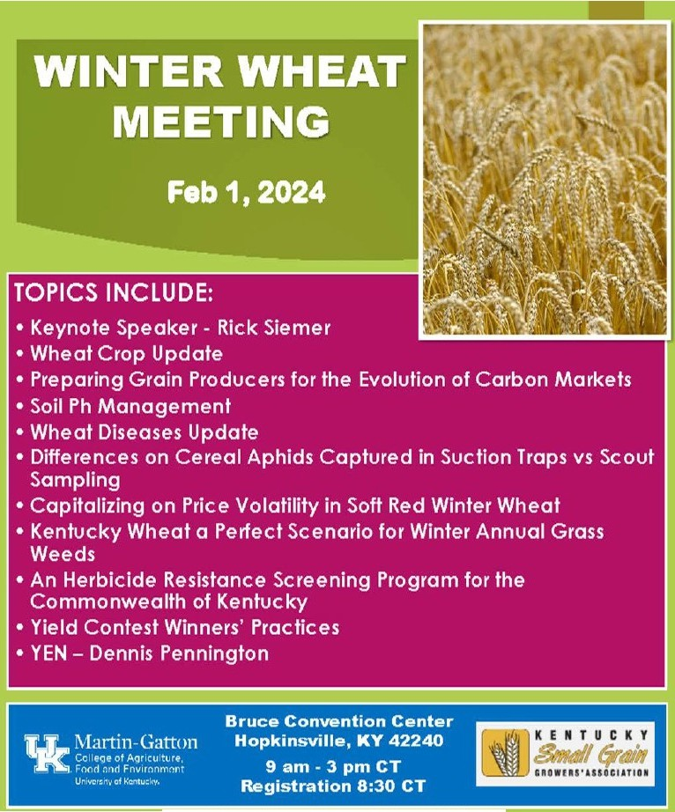
For additional information email claurent@uky.edu

Nil'""-''-••N.kifM aooQII-,•
+H"-h
MldkOIIOftllC:
-• c ,... • .,....., ,.._
......-.....-...............,..... .....i,,,......_..,........._...,....._..t.a\.._.,.,


- I
== ,, , .!: a.=.-

l-f.tllllll11.. , KT411Ma

What Should I Do With My Heifers?
Hannah Baker, University of Florida Extension

A common question asked each year by cattle producers is, “What should I do with my heifers? Should I raise them as replacements or sell them as weaned heifers?” This question is especially relevant in today’s market of high prices and the inevitability that expansion will have to start at some point. The answer involves penciling out the expenses and deciding which option best suits an operation in the current market. Costs of developing heifers include the current value of weaned heifers (opportunity cost), variable expenses, breeding costs, fixed expenses, and absorption costs. The Replacement Heifer Calculator discussed in this article aims to serve as a guide in organizing each of these costs and can be used as an estimation tool to calculate what it may cost to
develop heifers on a specific operation and if it is economical to do so. The calculator includes several key cost concepts, including:

- The opportunity cost of selling weaned heifers must be recognized. “What revenue will be forfeited if I
decide to raise these heifers rather than selling them now?” Understanding the opportunity costs allows for comparisons at the end of the estimation process to see which option is the most economical for an opera- tion.

- Variable expenses (feed, medications, and pasture management) and fixed expenses (land rent, labor, and interest) are important for calculating what each heifer needs so that she will be 60-65% of her mature body weight at the time of breeding. A way to remember what costs will go into these sections is to ask: “What is needed for the health and nutrition of the heifer?” Variable expenses will vary across operations and from year to year due to fluctuating input costs. Fixed costs should remain roughly the same year to year but will vary across different operations. Interest is included to account for the time between the op- portunity to sell them as weaned heifers until they are developed.

- Breeding costs are just that: “What is it going to cost to breed each heifer?” Whether you are using bulls or artificial insemination (AI), there are costs associated with both. Using natural service involves the costs of purchasing and maintaining the bull or bulls. Annual cost is determined using the following formula:
((purchase cost – useful years in the herd)/value at culling). A bull’s maintenance cost is his total variable costs, similar to a heifer’s variable cost: “What are the costs associated with maintaining the health of a
bull?” The annual bull cost plus the maintenance cost divided by the number of heifers he will be expected to breed is his total cost. This total cost is then multiplied by the number of bulls needed, and then divided by total number of heifers to calculate the breeding cost of each heifer.

- Absorption costs represent the cost of developing open heifers. These costs are absorbed by the bred heif- ers that remain in the operation. However, absorbed costs can be offset by the revenue from selling those developed, open heifers. The cost to develop all heifers is multiplied by the number of open heifers and then divided by the number of bred heifers to assign additional development cost to each bred heifer (cost absorbed). The revenue received by the sale of open heifers is then divided by the number of bred heifers to offset the additional development cost (revenue absorbed). All totals from each section can now be
summed to estimate the cost of developing heifers.
As an example, current prices for weaned heifers in Florida have been well above $2.00 per lb. since April 2023 and are continuing to rise. Prices for replacement cattle, open or bred, can be expected to follow the same trend in Florida as the demand for and value of replacement cattle increases when expansion begins to occur. Understanding the full cost to develop heifers allows you to compare that cost to selling heifers at weaning and buying bred replacements. If the price of bred heifers is greater than the total cost to develop bred heifers, a
potentially profitable investment has been made in your heifers. Of course, also important to the decision is your strategy for genetic development, which must be weighed against the value of weaned heifers, develop- ment costs, and the cost of purchased replacements. These decisions are all about the goals and risk manage- ment strategies of each operation. According to the example in Table 1, the total cost to develop 100 heifers is
$172,250 or $1,722.5/hd.
What Should I Do With My Heifers?, Continued;
However, after considering the revenue of selling 10 open culls, the net development cost is reduced to a total
of $150,650 or $1,673.89/hd for each of the remaining 90 bred heifers. The current value of young, bred re-
placement cattle with an average weight of 1,100 pounds is $1.54 per lb. or roughly $1,700/hd in Florida. Us- ing the results of the example, you would save approximately $27/hd or a total of $2,430 if you raised your
replacements (90) rather than buying them. Even though the price you would have received for selling weaned heifers is higher than the cost of development, the long-term outcome in this scenario suggests that the cost of development was worth the investment. With the value of female cattle expected to rise in the coming months due to inevitable expansion, raising your own replacements to rebuild your herd may be a more economical
decision. Expenses can be overwhelming when looked at as a short-term lump sum. So, it is important to look at them as long-term investments when possible. To download the Replacement Heifer Cost Estimation
Tool click here. The file will be located under ‘calculators’.

Table 1. Raising Replacement Heifers in Florida
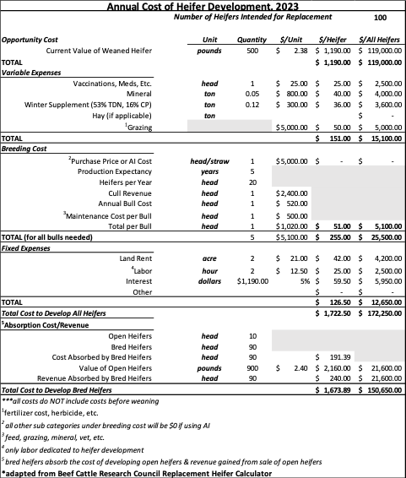



Thomas Butts
University of Arkansas
Topic: Drone Herbicide Applications: What Do We Need to Know for Success?

Carl Bradley
Universrty of Kentucky
Topic: Red Crown Rot of Soybean: Disease Management and Potential Impacts of this New Disease on Soybean Production in Kentucky

Raul Villanueva
Universityof Kentucky
Topic: Abundance of Emergent Pests in the 2022-23 Cornand Soybean seasons in Kentucky
Nicholas Seiter
University of Illinois Umana-Champaign
Topic: Above- and below- ground traits for insect management in com - new tools, old pests, and resistance
Gregory Tylka
Iowa State University
T01>ic: Soybean Cyst Nematode: Past, present, and future

Travis Legleiter
University of Kentucky
Topic: Dealing with the Stretch - Early Planted Soybean and Weed Control

Kiersten Wise
University of Kentucky
Topic: It's always something! New com disease concerns for Kentucky

Upcoming Events

2024 CPH60 Sale Dates
Feb 15, April 25, Aug 8 and Dec 5

Lawn Care and Fruit Tree Program
March 19 ,2024
5:30pm Union Co Extension Office

Italian Ryegrass Control Field Tour
March 28,2024

Wheat Field Day
May 14,2024

Corn, Soybean and Tobacco Field Day
July 23,2024



Owensboro Convention Center For more information:
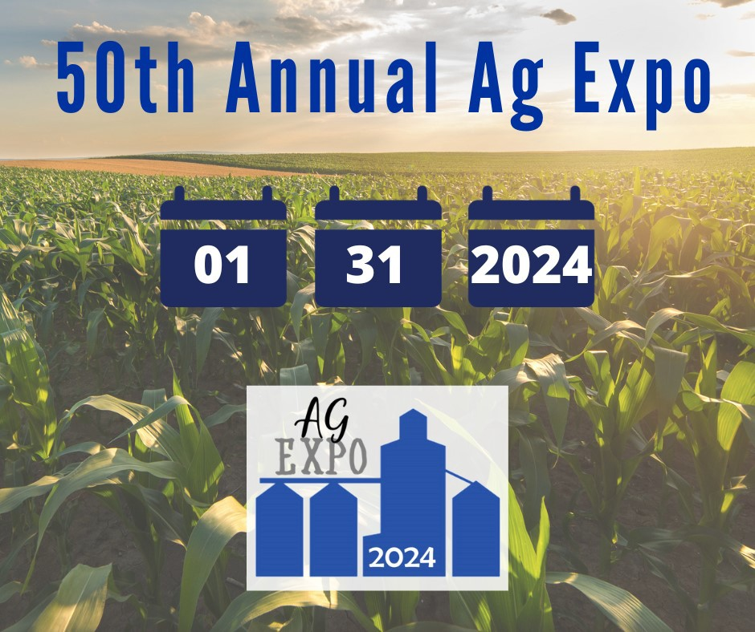

https://daviess.ca.uky.edu/Ag- Expo-2024
Or
Contact Clint Hardy
270-685-8480



2023-2024 Ag Economic Situation & Outlook
UK Ag Econ Extension
Macro Ag Economy U.S. and Kentucky Farm Economy 2023 Situation
Following an amazing run in 2021 and 2022, the agricultural economy is expected to retreat in 2023. Prices for
most major farm commodities were lower in 2023 as the global producers responded to price incentives induced by tight global stocks and trade opportunities. In addition to increased global competition, the U.S. ag economy was adversely affected by slumping exports, interest rate hikes, labor challenges, unfavorable weather patterns impact- ing crop yields and pasture conditions, along with the volatility caused by ongoing global geopolitical issues.
The lone bright spot in the ag economy in 2023 was cattle markets where farm-level prices soared in response to tight cattle supplies and a resilient beef consumer base even amidst relatively high retail beef prices.
While inflation moderated in the second half of the year, the ag sector continues to be adversely impacted by infla-
tionary pressures on the economy. Despite lower fertilizer and feed expenses, overall farm production expenses
were higher in 2023, primarily due to higher interest expenses (with farm loan rates exceeding 8%) and labor costs. In addition, government farm payments receded to pre-trade war/pandemic levels. In aggregate, USDA is forecast- ing that U.S. net farm income will decline by 17% in 2023, following record-high levels in 2021 and 2022. Despite a significant decline, the projected 2023 U.S. net farm income level adjusted for inflation will still be the fourth- highest real net farm income realized in the past 75 years.
A significant portion of the growth in farm income in recent years has been a strong international market for U.S. farm commodities and ag products. However, U.S. ag exports, which generally account for over 20% of U.S. ag production, declined in 2023 in response to a stronger U.S. dollar, a weakening global economy, and rebounding world stocks. The biggest decline occurred in our largest ag export market – China which faces a lot of economic challenges as its economy continues to try to recover from COVID and other financial stressors. The decline in
U.S. ag exports, coupled with continued growth in ag imports will likely cause the U.S. ag industry to experience its third trade deficit in the past five years – very uncharacteristic given that the U.S. ag sector historically has rec- orded relatively large trade surpluses.
The Kentucky agricultural economy has not escaped many of these national macroeconomic issues and trends, but our diverse farm economy, better-than-expected grain yields amidst weather challenges, and carryover grain sales from the 2022 crop helped cushion some of the downfall. As a result, University of Kentucky agricultural econo- mists are projecting that 2023 Kentucky ag cash receipts will decline modestly from its record high level of $8.3
billion in 2023 to $8.1 billion as the significant increase in cattle (+22%) and wheat receipts (+30%) are just slight- ly offset by lower receipts for corn (-18%), soybeans (-6%), dairy (-15%) and tobacco (-10%). Poultry will likely
remain Kentucky’s number one commodity in terms of cash receipts, but strong cattle prices vaulted cattle receipts over corn, soybeans, and equine receipts in 2023. Similar to national trends, production expenses will be higher for most Kentucky farmers this past year while government payments will fall leading to net farm income for Ken- tucky agriculture declining in 2023 from record highs of $3.1 billion in 2021 and $3.9 billion in 2022. While the
outcomes will vary across enterprises and farmers, overall net farm income adjusted for inflation for Kentucky this past year is expected to remain above the $2.5 billion average recorded over the past ten years.
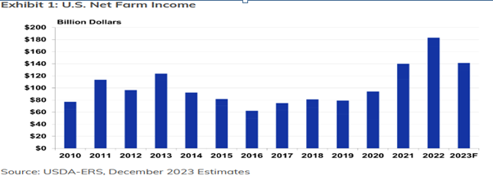

2023-2024 Ag Economic Situation and Outlook, Continued;

2024 Outlook
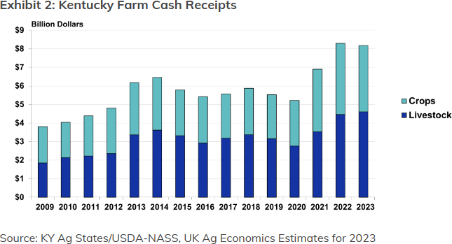

Looking ahead to 2024, commodity prices, except for cattle, will continue to face
headwinds amidst global competition, higher stock levels, and a slowing global
economy. Despite challenges, Kentucky ag cash receipts may still remain above $8
billion on the heels of expanding livestock receipts and anticipated stable crop re-
ceipts. While inflation has eased in recent months, the current macroeconomic envi-
ronment does not indicate that interest rates will likely fall dramatically in the coming
year. Labor costs will continue to rise as the H2A wage rate is bumped up 6% to $15.14 per hour. Feed and fertiliz-
er costs have moderated from recent highs, but remain above historical levels. Despite political drama in DC, we will have some sort of farm bill in place, but one that will likely deliver very little changes in price/income protec- tion leading to lower government payments with conservation funding being the wild card. After trending up the
past few years, the value of the dollar could soften some in 2024 if the Federal Reserve begins to ease its recent re- strictive monetary policy. However, a slowing global economy along with export market competition will continue to challenge U.S. ag export growth.
Collectively, lower/stable crop prices, in- tense export competition, higher interest and labor expenses, and limited govern- ment payments will challenge potentially higher livestock receipts in the coming
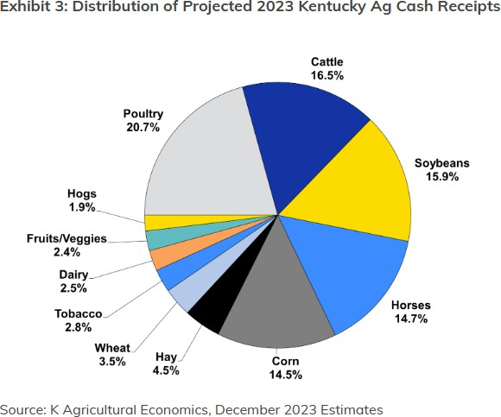

year. Even accounting for narrowing profit margins, the ag balance sheet remains rela- tively strong heading into 2024. Ag loan portfolios have benefited in recent years from the ability of farmers to utilize excess cash to pay for operating expenses, land, and equipment holding down increasing
debt levels. However, higher interest rates and the depletion of cash/working capital in a lower net farm income environment may cause lenders to be more cautious in the coming year in evaluating loans. De- spite these economic challenges, the farm
economy outlook remains relatively positive heading into 2024. However, as usual, extreme/unpredictable weather events and uncertain geopolitical actions could quickly disrupt markets and forecasts emphasizing the need to incor- porate various risk management tools to counter potential market volatility.

Ag Economic Situation & Outlook | Agricultural Economics (uky.edu)
Annual Ag Economic Situation & Outlook publication is a collaborative effort between the Department of Agricul- tural Economics Extension Faculty and the Department of Forestry and Natural Resources. Link above will show
the livestock, grains, specialty crops/forestry and Kentucky profitability.

2024 KVAlfalfa andSto1red Forage,conference

,Getting Started in the Hay Business

WHEN
Thursday,. February S,.
2024
8:00 to 3:30 CT
WHERE
Warren County Extension
O'fflce
5162 Russellville Road Bowling Green,. KV 42101
COST
$40 General Admission
$15 Students (Includesrefreshments. catered lunch.printed proceedings)

S:00 Registration, Sponsor !Displays, Silent Auction
S:4S Welcom,e and Program HighHghts,
Dr_ Ray Srnit:h, Forage Specialist:, Universit:y oF.Ken"t:ucky
9:00 Operating a Maj,oir Hay and Strall\l Farm 1nOhio
John Russell, J_D_ Russell Hay and SlI:aL11", Pemberville, Ohio
9:45 Teaching Hay Buyers What The1r Horses ReaHy Need
Dr_Laurie La:v.;rence, ProFessor, Equine Nu:t:rit:ion, Univer.sit:y or Kent:ucky
10:4S Hovv to Find and Evaluate Used Equipment
Dennis Wright:,. Airalra Producer in Logan Gounry, Kent:ucky
1.1.:15 Panel: Establlsh1ng a Market(s) for Your Hay and Stravv
Jeff Stephens, St:ephens Hay & St:rai,v, Ei,vin .Kent:ucl<y
Ellis Devveese, Devveese Hay Emporium, La Cent:er, Kent:ucl<y
1.1.:50 Lunch, Alfalfa Avvards, KCA Hay Quall1ty A.vvards, and Slllent .Auction WI nners 12:50 Kentucky Forage and Grassl!.and Councll Update
Brandon Sears Agri_ and Nat:urai Resource Agent:, Universi"t:y or Kent:ucl<y Kent::ucky Forage and ,Grassland Council President:
1:00 SOYears of Alfalfa Product1on 1n Kentucky: O•bservatlons, Reflectl•ons and O•pportu nltles
Dr_ Gary Lacenetd Prot=essor Ern·erit:us, Universizy or Kent:ucky
1.:45 Basics ,of Fertilizing for Successful Hay Piroductlon
Dr_Edi,vin Rit:chey Soil Ext:ension Specialist: Universi"t:y ot=Ken"t:ucl<y
2:10 Hovv I Got Started 1nthe Hay Business: The Good, the Bad, and the Ugly
John Russell, Clayt:on Geralds .D·ennis Wright: Brad Hines
3:15 Take-Home Lessons fr,on, Today's Meeting
Dr_Ray Srnit:h, Forage Specialist:, Universiry oFKent:ucky


, \ / Ken·tucky
Fora eand


f,t:- G assland
·"->J"' Council
I<entucky Master Grazer ducational Progra1n.
2024- KV A.lfa..lfa.. c1.r11cl Ste>1rec:I Fe>rc1.g•e C<>r1ferer11c::•e
C:;;E?ttir,g .StClrtE?c::I ir> thE? I--ICf'_y E3LIS:ir>E?SS:
1·his pre>gr.a..m is d-e-:signecl fci,r :a.Lfa.lf:a. a.nc:I hay prc,ducer:s te>learn mc,r,e- :a.be>ut impre>ving 1:.heir hay yield. haypre>,duction, marketing and promotie>n

WHEN
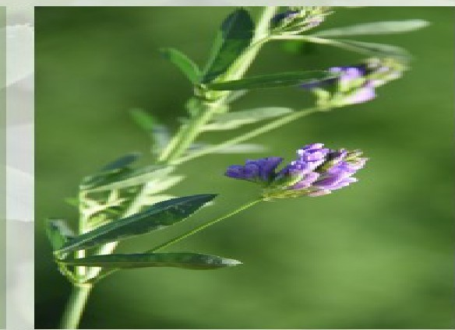

Thursday. February a. :ZC>:Z4
8:00 tc»3:30 C::T

WHERE
vvarren county Extenslc»n C>ft"lc:e
!5162 RussellV'ille Rc»a.cl Bc»vvllng Green. KV 42101

C::C>ST
$40
(lnclucle-:s re'W'reshment:s. catered lunch,
_prlnte,CI prc:.c••cllngs}
Register online• by scann1ing the QR c::ocle Vtlirth y-c>u . camera_'!I

-- -
-
11!!1. - -- - -

SCANHERE

https://2024-A.S FCc:> nfere r1c::e.e-...,·er1tb rite.cc:> m

l'VI-a~.il--in-i Re-,-g-i-s-t-,r-a-.-t-i-<-:->171-1
,_ ·

Na.m,e::
A.c:licl .--ess:
Phe>l'"lle Niu m,be..-·:

Em.a.It.:
# o,f tii ck::ets
<Sieneiral Adm iissii on
# of tiic::k.et:s
s-.:ud1en-c
.A.c:lmi.s:siio,..----.

K-e-ntu,cky For.age and Grassland C:e>uncil
X $--4--0 X 15
rv-:11.a.ke checks pa..y·a.bl-e- t.c:,
KFGC: (Kentucky F•ora..g•e and Grassland,c::o.rL!I nciil) a.nc:I :s.e-nc:I tc:,:


u niv·,ersiity of K.entuc:k.y REC
A.t.tn:: C:::.a.roliill'llle Rc:,p,e.r 34-.s u·ni-v,ersiity Drive PII"" in ce-to n, KV",42:44-5

TJi.. Cooperative
1K. Extension Servfre Daviess County

Emerging Marketing Approaches and Opportunities for Farmers' Markets
Presented by Dr. Tim Woods,
Extension Professor of Agricultural Economics January 25, 2024, 6:00 p.m.
Daviess County Cooperative Extension Service Office
,-----------
4800A New Hartford Rd., Owensboro, KY 42303
IYou will learn: I


I1. New product ideas for farmers' markets I
I2. Tools for selling local products to local I
I market patrons I
- --·
13. Ways to make product sampling easier 1

Applies to all types of vendors/products!

I-Fo-r mor-e info-rmati-on, co-ntact-the D-avies,s


I
..
,
County Cooperative Extension Service I
at 270-685-8480.



Annette Meyer Heisdorffer Daviess County Extension Agent for Horticulture Education

Cooperative
Extension Service
A,tncul,urc :illll 'l(;inmll Ralt1t111.'a
F11mil)·andCom.umtt S('i(l'l(rc
-t H YouthDt'Yttlopm"''
COmJJu1n1ry and Ccono1111c Oi.'\:tkipmcni
IARTI:--:-GATTON COLLEGE or ACRI CULTURE. 1'001) AND ENVIRONMENT
r.11,c_.,_, ,.,...,,...., ,.i.rc- - &10",_,..._;i1, ,_N,.,,..11f a --.1,. u•


Phi • m- 41tm,.._tlift dwb..bllfI-, nhnltonrJn, •*"°""c,r!Ji11.at«d.rctip;,n.p:l111ul brk(.....
w.\lAl0--1;11i,,,n. -Ill}#A4rfCl(l)l1'Ul(,n.prq:n_,;y. .i•111,p11dl• in ma.11,..,,,_....,,,..1can11tJu,
..C-.jJot nw.w:al illlyor,,..ll'hial11t mai11:kln br pt101a"1I r15U,KTil1Cf lll'MOn•..-a)lllmod11.,. I)(ckUblllly
Ill.Ilrt<11 •,•11\ P""'lllllll'lr.f'mi,·.un i,iS.ormll-lr,;I}bf m.vk-W.\-: oditt !MIitnd,,h
l'll"W.I!)' f)fktl'f:IKk... l:fflutl)'ll,_va,.,,,..r,e,•,!,.:S.l><,la!lfM'4fl'JIA....--Ul'f.1111d Kt'lliucly0wnl Fl!U'\I
1.,,unsi11n. KY 1QKl6


Cooperative Extension Service


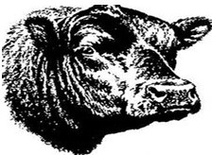

22nd Annual Union County Bull Sale February 24, 2024
33 BULLS
All bulls have passed a Breeding Soundness Evaluation within 45 days of the sale All Bulls have been DNA tested / Genomic Enhanced EPDs
Breeds Represented:
Angus (28) / Gelbvieh (2) / Red Angus (1) / Charolais (1) / Hereford (1)
COME VISIT OUR TRADE SHOW
$50 Credits for bull purchases to given away prior to sale
LOCATION
Union County Fairgrounds - Inside the John A. Arnold Arena - Sturgis, KY 1 Mile West of Sturgis on Hwy 60
125 Pryor Boulevard, Sturgis, KY 42459
CONTACTS
Caleb Jenkin, Sale Manager (270-952-0767) Ben Lloyd, Kentucky Beef Network (270-993-1074)
Katie Hughes, Union County Extension Agent (217-891-0947)
SALE INFORMATION
Bulls and Trade Show will be on display at 10:00 A.M. Lunch Served at 12:00 P.M.
Bulls will sell at 1:00 P.M.
Meal By: Livingston County Livestock, INC & Ross Meat Packing Company
***Check out our Facebook Page (Union County Bull Sale) for videos or Scan below***


Cooperat:ive
Extension Service
MARTIN-CATTON COL1...EC£. or- ACRICU1,.:rURE. FOOD ANO 1::NvrRONMENT
tAiuc••·h,,.•1ProtW•m• of Ken•ucky Coop,eni,·i,•e g,,,..,..,._!on,.......,•II r>CQple ...,._,.dl..-N u(ee<.<1>0mlc or IOOClal ..,,"""

t\ rlculturc and Nalural Hc,..;,urcc" Family and <;:nn•umcr Sclcncc"
◄·• I Youth l:Jcv.:lo1>n•cnt
Com,nuni1y ,.,.,d Rconon,lc l">cv<.,loi,n,cn•
;,n,I _,II nno,..,_,.,.,.,,.,.,., ,.., ,1,., """"'•<>ir..a,.c,nk>•r .,.,h.,,,c:.-.,aw,., ,..,,nn;,,I '"'MC'"• c.-.:,cJ, .-o,11,ctnn. pnlhoc;,,I ....,.. .,,.-••
""'"u•l ort,cnt,u«......l<'Ot><kr u.1<,noi1y• ..,_,.,,."-'"P""• .._..,_ p.-,.,...,,.ncy. ..,..,,.1,,.1 .., ......... l<'t"n<:'00C onforn,,nton, •1<<.". ,,,,..,.••n .,,., ,
phy,oka• or..,.,,.,,.,J,,.,.h,luy .-,,- n.,p,1•..I .,,,.,,,.h•<lun fur 1>rk',,.-.,,,..,1,1,.h,,. <><:u.. uy llc.•a_.m,.hlc ............. ,.,J,.,..,..,ofd,,. l,11!,,,
m•y ax,••••ll ..bk: -i•h r,,-lor no,1._...., P••••••"' lnform,ooic,n nuoy Ix- m•J.., ..... •••bl.., In ...._,u....,..••1'h<:r oh•n Y.n11li"h
..,.,,,,,.,,,.uy"'fK.,,uuclo.y. K,.;_,,...,,.,,.. NO,,.,., Unh-.,,.,1,,-. U- · 1>c1_,,..,., .. , .. r ,._....,t.,uUun>, anJ Ko,nt...:,kyCttuoHI.._;. c.:.-.. ,...,,,.tl,. ,_

-
6.
Dl •bllhlc,1
-,,::ommoJ..iel
wl1h pr;o, no,ll'kanon

Lot Owner
-1 Renee Grove
2 Dale Downey -
-3 Jeff Pettit -
Breed Hereford Charolais Red Angus
Sire
KT Small Town Kid PC Bobs Wrangler Brown BLW Fantasti
Docilitv

. -
Milk
27
24
30
Registration I CAIP
P44246525
- M982700
- 4574281

-4 Wes Lasher -
-5 Wes Lasher -
-6 Lloyd Boys --
-7 Danny Gray --
-8 Danny Gray --
-9 Danny Gray --
Gelbvieh Gelbvieh Angus Angus Angus Angus
Square B True North LWHF Thunder Byergo Black Magic H P C Mc Clintock
SydGen KCF Gavel -
SydGen KCF Gavel -
- 13 -
- 13 -
24
-
30
-
. 25 -
- 25 -
28 -
21 -
25
-
27
-
38 -
35 -
1547431
1548509
20486202
20739749
20739748
20739750

10 Lloyd Boys --
Angus
EXAR Stock Fund -
. 30 -
37 -
20759241

1- 1 Tim Gardner --
1- 2 Lloyd Boys -
1- 3 Jimmy Gilles -
Angus Angus Angus
EXAR Stock Fund Kesslers Commodore Tehama Patriarch
. 32 -
. 26 -
. 28 -
33 -
18 -
30 -
20569518
20759282
20655792

1- 4 Tim Gardner --
1- 5 Tim Gardner
-
Angus Angus
EXAR Stock Fund -
SydGen Enhance
-
28 25
27 31
- -
-
-
-
-
20633412
20569517

1- 6 Jimmy Gilles -
1- 7 Danny Gray --
Angus Angus
Tehama Patriarch
SydGen KCF Gavel -
. 12 -
. 20 .
22 -
38 -
20655795
20809647

18 Danny Gray --
1- 9 Tim Gardner
Angus Angus
BAR Dynamic --
SITZ Milestone
-
-
. 24 .
. 15 -
38 -
24 -
20809641
20569523

-20 Pinewood Farms
Angus
Coleman Bravo
. 28 -
28 -
20611849

-21 Danny Gray -
-22 Jimmy Gilles -
-23 JS Cattle --
-24 Danny Gray
Angus Angus Angus Angus
BAR Dynamic - EXAR Stock Fund - SITZ Milestone - SydGen KCF Gavel -
. 20 -
21
- -
16
- -
. 6 -
20 -
30
-
28
-
40 -
20809646
20655766
20714803
20809645

-25 Pinewood Farms
-26 Pinewood Farms
-27 JS Cattle
-28 Pinewood Farms
-29 JS Cattle
Angus
Angus Angus Angus Angus
Poss Deadwood -
SAVAmerica --
E&B Plus One
-
Poss Deadwood -
EXAR Stock Fund -
. 22 -
. 31 -
. 17 -
. 28 -
. 37 -
22 -
26 -
27 -
22 -
39 -
20611836
20611832
20714834
20611837
20714727

-30 Pinewood Farms
Angus
Square B Atlantis
-
22 26
- - -
20611834

-31 Danny Gray --
-32 Danny Gray -
Angus Angus
BAR Dynamic -
GAR Inertia
14 28
- - -
24 27
20809642
20819047

33 Danny Gray
Angus
Springfield Ramesse
21 24
20809643

CAIP BT- Balanced Trait Bull, CAIP T- Terminal Bull, CAIP HB- Heifer Acceptable Bull
 | DOB | CE | WW | YW
 | 2/11/2020 | 11.5 | 57 | 90
 | 9/1/2021 | 10.6 | 56 | 98
c | 10/17/2021 | 14 | 67 | 106
 | 8/28/2022 | 14 | 76 | 122
 | 9/12/2022 | 13 | 65 | 94
 | 8/28/2021 | 0 | 95 | 162
- | 2/8/2022 | 10 | 86 | 147
 | 2/12/2022 | 8 | 73 | 132
 | 2/12/2022 | 6 | 82 | 150
 | 8/16/2022 | 14 | 73 | 129
 | 8/25/2022 | 11 | 80 | 142
 | 8/27/2022 | -2 | 77 | 133
- | 8/27/2022 | 12 | 59 | 117
 | 8/28/2022 | -4 | 91 | 168
 | 8/29/2022 | 8 | 62 | 114
- | 8/30/2022 | 14 | 58 | 113
 | 8/31/2022 | 5 | 70 | 123
 | 9/2/2022 | 11 | 71 | 131
 | 9/7/2022 | 11 | 79 | 139
 | 9/12/2022 | 9 | 61 | 110
 | 9/14/2022 | 0 | 82 | 140
 | 9/16/2022 | 10 | 92 | 159
 | 9/16/2022 | 3 | 65 | 115
 | 9/17/2022 | 2 | 66 | 125
 | 9/18/2022 | 10 | 64 | 113
 | 9/18/2022 | 5 | 84 | 146
 | 9/22/2022 | 7 | 64 | 113
 | 9/23/2022 | 9 | 61 | 114
 | 9/25/2022 | 9 | 74 | 139
 | 10/5/2022 | 1 | 71 | 117
 | 10/22/2022 | 14 | 73 | 131
 | 11/15/2022 | 14 | 63 | 120
s | 11/15/2022 | 10 | 78 | 136

8: 00 AM Registration
Field Crops
2024 IPMTraining School
March 181\ 2024
Program

8:2SAM Herbicide Resistance Screening in the Commonwealth of Kentucky 8:50AM Herbicide Resistant Weed Control
9:15 AM Cover Crops
9:40AM Keeping Cove, Crops from Becoming a Pest Problem

10:05 AM Break
10:20AM Management of Important Soilborne Diseasesof Soybean
10:45 AM Efficacy of Insecticides in St-and non-Bt field Corn andProblems Capturing Pest Moths

11:10 AM TheAgronomics andEconomics of VariousNutrient Sources for Crop Production 11:35 AM Application of low ost GPS Technologies to Improve Input Use

Horticulture
1:00 PM Understanding the Mildews- Downy versus Powdery 1:25 PM Greenhouse Disease Management
1:50 PM Cover Cropping in Vegetable Production Systems: Benefits, Challenges, and Considerations
2:15 PM Break
2:30 PM Eve,ything Old isNew Again
2:55 PM Impact of Invasive Species on 1PM
3:20PM Current and Future Wildlife Management Conflicts for the Mid•South
Dr. Samuel Revolinski Dr. Travis Legleiter
Dr. Lloyd Murdock Dr. ChodLee

Dr. Corl Bradley
Ors.Ric Sessin RaulT. Vil/onuevo Dr. Edwin Ritchey
Dr. Chris Teutsch

Dr. NicoleGouthier Ms.Arundothi Sharma
Dr. Rochel Rudolph

Dr. ShownWright Dr.Jonathon Lorson Dr. Matt Spn'nger

To attend in person or online, please click to register

FieldCrops
Pesticide Applicators
CEUs
Category l.A: 4
Certified Crop Adviser
CEUs
Soil & Water Management:1

1PM 2
Crop Management: 1

Horticulture
Category l.A: 3 1PM 2

Cro Mana ement: 1

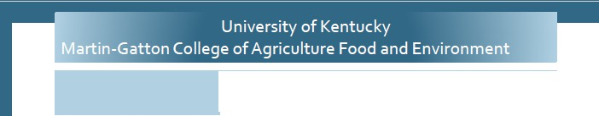

Location
Warren County Extension Office
5162 Russellville Rd. Bowling Green, KY 42101
Contacts

Zenaida Viloria
zenaida.viloria@uky.edu (270)
365-7541 Ext. 21336

Ric Sessin
r.bessin@uky.edu (859) 323-1120

Extension Office will be Closed:
Jan 15,2024

Katie Hughes
UK-Union Co Extension ANR Agent
270-389-1400
Katie.n.hughes@uky.edu
The College of Agriculture, Food and Environment is an Equal Opportunity Organization with respect to education and employment and authorization to provide research, education infor- mation and other services only to individuals and institutions that function without regard to economic or social status and will not discriminate on the bases of race, color, ethnic origin,
creed, religion, political belief, sex, sexual orientation, gender identity, gender expression, pregnancy, marital status, genetic information, age, veteran status, or physical or mental disabil- ity. Inquiries regarding compliance with Title VI and Title VII of the Civil Rights Act of 1964, Title IX of the Educational Amendments, Section 504 of the Rehabilitation Act and other related matter should be directed to Equal Opportunity Office, College of Agriculture, Food and Environment, University of Kentucky, Room S-105, Agriculture Science Building, North Lexington, Kentucky 40546, the UK Office of Institutional Equity and Equal Opportunity, 13 Main Building, University of Kentucky, Lexington, KY 40506-0032 or US Department of Agriculture, Office of the Assistant Secretary for Civil Rights, 1400 Independence Avenue, SW, Washington, D.C. 20250-9410.



Union Co Cooperative Extension Service 1938 US Highway 60 West
Morganfield, KY 42437-6246
RETURN SERVICE REQUESTED

For daily and local ag news, “LIKE” Union County KY Agriculture Extension on Facebook at www.facebook.com/UnionCountyKYAgricultureExtension

